Department of Computer Science and Engineering

Course Code & Name | CSA06 – Design and Analysis of Algorithms
Assessment | CO1 – Assessment Tool 1: IT Application-Based Problem Solving –Scalability Audit of an E-Commerce Platform
Course Outcome Assessed | Determine algorithm efficiency using asymptotic notations andmathematical techniques including Master Theorem and substitutionmethod.
Duration | 3 Days
Mode | Individual
Student Reg. No. | 192511131
Student Name | Teeka Raman S

Instructions: Answer all parts. Show the basic operation, every step of each derivation and the finalasymptotic result, and interpret what each result means for the platform. Assume the platform’sservers execute 10⁸ basic operations per second.
IT APPLICATION-BASED PROBLEM
Scenario – Scalability Audit of “ShopSphere”, an Online Shopping Platform: ShopSphere is agrowing e-commerce platform whose product catalogue currently holds n = 100,000 products and is expected to reach n = 1,000,000 within a year. Before the expansion, the CTO has asked you, asthe platform’s algorithm engineer, to audit five back-end modules, predict how each will behave as n grows, and recommend which modules must be redesigned. The modules are described below.
Module M1 – Duplicate-Listing Detector: Sellers sometimes upload the same product twice.
Every night, the following routine compares every product with every later product.
FOR i ← 0 TO n − 2 DO
FOR j ← i + 1 TO n − 1 DO
IF Product[i].title = Product[j].title AND Product[i].seller =
Product[j].seller THEN
MarkDuplicate(j)
END IF
END FOR
END FOR

Module M2 – API Rate Limiter: The public API audits request windows of doubling size using
the routine below. A team member claims that it is Θ(n log n) because the outer loop runs about
log n times and the inner loop runs up to n times.
i ← 1
WHILE i &lt; n DO
FOR j ← 0 TO i − 1 DO
Audit(Request[j]) // basic operation
END FOR
i ← i × 2
END WHILE

Module M3 – Product Search: Two versions exist. Version S1 scans the unsorted catalogue
sequentially until the product is found. Version S2 searches a sorted product index by

comparing the key with the middle entry and discarding half the index after each comparison; its
comparison count satisfies T(n) = T(n/2) + 1, T(1) = 1.
Module M4 – Recommendation Engine: The engine splits the customer–product data into
four parts of size n/2 (because of replicated partitions) and merges the partial results in linear
time: T(n) = 4T(n/2) + n. A proposed redesign removes the replication, giving T(n) = 2T(n/2) + n.
Module M5 – Sales Analytics Engine: The analytics engine splits the sales data into halves
recursively and sorts the records by revenue at every level, giving T(n) = 2T(n/2) + n log n.
Separately, profiling shows that the nightly report generator performs f(n) = 3n² + 10n log₂ n +
50 operations.
(a) Understand the Problem: For each of the five modules, identify the input size and the basic
operation that dominates the running time, explain where it occurs, and state how you expect its
execution count to grow as n increases. Justify each choice briefly.
(b) Analyse the Iterative Modules: For M1, derive the exact number of comparisons as a
function of n and state the time and space complexity. For M2, derive the exact number of Audit
operations, decide whether the team member’s Θ(n log n) claim is correct and give the tight
bound. Verify your M2 result for n = 1,024.
(c) Solve a Recurrence by Substitution: Solve the recurrence for search version S2 using
backward substitution, showing every intermediate step, and derive the exact closed form. State
the time complexity and the space complexity of both an iterative and a recursive
implementation.
(d) Apply the Master Theorem: For M4, apply the Master Theorem to both the current design
and the proposed redesign, clearly identifying a, b, f(n), n^(log_b a) and the case used, and
explain what happens to the running time when the data doubles. For M5, determine whether
any of the three standard cases applies to T(n) = 2T(n/2) + n log n; if not, derive the complexity
using the extended Master Theorem or a recursion tree.
(e) Analyse Best, Average and Worst Cases: For search versions S1 and S2, identify the
input condition that produces the best, average and worst case and give the number of
comparisons in each. For S1, derive the average number of comparisons when the probability
that the searched product exists is p, and evaluate it for n = 1,000,000 and p = 0.5.
(f) Prove an Asymptotic Bound: Using the formal definitions, prove that the report generator’s
cost f(n) = 3n² + 10n log₂ n + 50 is Θ(n²) by finding constants c₁, c₂ and n₀, and show that
f(n) is not O(n).
(g) Scalability Decision: Estimate the number of basic operations and the running time of M1,
M2, S2, M4 (both designs) and M5 for n = 1,000,000. Identify the modules that will fail to meet a
nightly processing window of 10 minutes, and recommend, with justification, which modules
must be redesigned and how.

Implementation
M1 — Duplicate-Listing Detector
total = int(input("Enter the number of products: "))
catalogue = []
for idx in range(total):
name = input(f"Title of product {idx + 1}: ")
vendor = input(f"Seller of product {idx + 1}: ")
catalogue.append((name, vendor))

checks = 0
duplicate_found = False
print("\nDuplicate listings:")
for first in range(total - 1):
for second in range(first + 1, total):
checks += 1
if catalogue[first] == catalogue[second]:
print(f"Product {second + 1} duplicates Product {first + 1}")
duplicate_found = True

if not duplicate_found:
print("No duplicate listings found.")
print("Number of comparisons:", checks)

Output

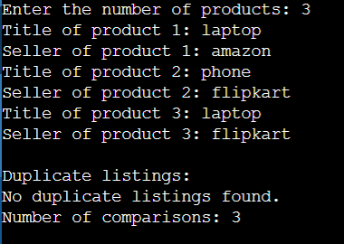
M2 — API Rate Limiter
n = int(input("Enter the number of requests: "))
window = 1
audits = 0
while window < n:
for k in range(window):
print("Auditing request:", k)
audits += 1
window *= 2
print("Number of audit operations:", audits)

Output
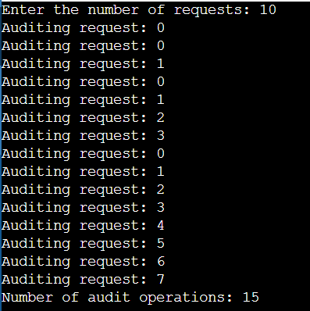

M3 — Product Search (A: Linear Search)
count = int(input("Enter the number of products: "))
items = [input(f"Product {k + 1}: ") for k in range(count)]
key = input("Product to search for: ")

steps = 0
position = -1
for k in range(count):
steps += 1
if items[k] == key:
position = k + 1
break

print(f"Product found at position: {position}" if position != -1 else "Product not found.")
print("Number of comparisons:", steps)

Output

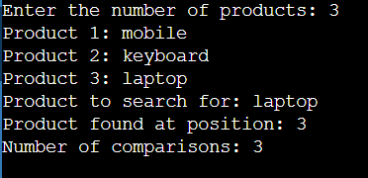

M4 — Recommendation Engine
def current_cost(n):
if n <= 1:
return 1
return 4 * current_cost(n // 2) + n

def redesigned_cost(n):
if n <= 1:
return 1
return 2 * redesigned_cost(n // 2) + n

size = int(input("Enter the input size (power of 2): "))
print("Operations, current design:", current_cost(size))
print("Operations, redesigned version:", redesigned_cost(size))

output
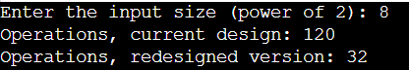
M5 — Sales Analytics Engine
def sort_by_revenue(records):
if len(records) <= 1:
return records, 0

centre = len(records) // 2
left_part, left_cmp = sort_by_revenue(records[:centre])
right_part, right_cmp = sort_by_revenue(records[centre:])

result = []
a = b = 0
cmp_total = left_cmp + right_cmp

while a < len(left_part) and b < len(right_part):
cmp_total += 1
if left_part[a][1] <= right_part[b][1]:
result.append(left_part[a])
a += 1
else:
result.append(right_part[b])
b += 1

result.extend(left_part[a:])
result.extend(right_part[b:])
return result, cmp_total

n = int(input("Enter the number of sales records: "))
data = []
for k in range(n):
oid = input(f"Order ID {k + 1}: ")
amount = float(input(f"Revenue of order {k + 1}: "))
data.append((oid, amount))

ordered, cmp_count = sort_by_revenue(data)
print("\nSales ordered by revenue:")
for oid, amount in ordered:
print("Order:", oid, "| Revenue:", amount)
print("Number of merge comparisons:", cmp_count)

Output

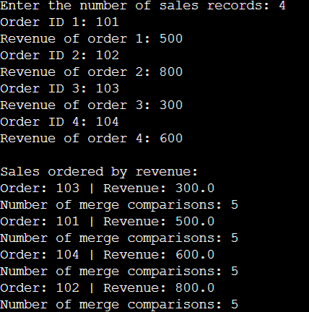
Answers

(a) Understanding the Problem
Module | Input size (n) | Dominant basic operation | Expected growth
M1 – Duplicate detector | Number of products | Title/seller comparison inside the inner loop | Quadratic, Θ(n²): every pair is examined
M2 – Rate limiter | Number of requests | Audit(Request[j]) call | Linear, Θ(n): window sizes form a geometric series
M3 – S1 linear search | Catalogue size | Key-to-entry comparison | Linear, O(n)
M3 – S2 binary search | Size of sorted index | Key-to-middle comparison | Logarithmic, O(log n)
M4 – current design | Customer–product data size | Merge step at each recursion level plus 4 subproblems | Quadratic, Θ(n²)
M4 – redesign | Customer–product data size | Merge step at each level plus 2 subproblems | Θ(n log n)
M5 – analytics | Number of sales records | Sorting work (n log n) at every level | Θ(n log² n)

(b) Iterative Modules
M1
For i = 0 the inner loop makes n − 1 comparisons, for i = 1 it makes n − 2, and so on down to 1 comparison for i = n − 2. Therefore:
C(n) = (n − 1) + (n − 2) + … + 1 = n(n − 1)/2 = (n² − n)/2
Time complexity: Θ(n²). Auxiliary space: O(1), not counting the stored products and the output. At n = 10⁶ the routine needs about 5 × 10¹¹ comparisons.
M2
The window i takes the values 1, 2, 4, …, 2^k, where 2^k is the largest power of two below n. Each pass performs i audits, so:
C(n) = 1 + 2 + 4 + … + 2^k = 2^(k+1) − 1 = 2^⌈log₂ n⌉ − 1
Since n ≤ 2^⌈log₂ n⌉ < 2n, we get n − 1 ≤ C(n) < 2n − 1, so C(n) = Θ(n). The claim of Θ(n log n) is therefore incorrect: the outer loop does run about log n times, but the inner loop does not run n times on each pass. It runs 1, 2, 4, … times, and these costs add up to a geometric series dominated by its last term.
Check for n = 1,024: i takes the values 1, 2, 4, …, 512 (the loop stops once i = 1024), so C = 2¹⁰ − 1 = 1,023 audits. This lies between n − 1 and 2n − 1, which is consistent with Θ(n).

(c) Backward Substitution for Search Version S2
T(n) = T(n/2) + 1, T(1) = 1.
T(n) = T(n/2) + 1
= [T(n/4) + 1] + 1 = T(n/4) + 2
= [T(n/8) + 1] + 2 = T(n/8) + 3
… after k steps: T(n) = T(n/2^k) + k
The recursion stops when n/2^k = 1, that is k = log₂ n (n a power of 2). Then T(n) = T(1) + log₂ n = 1 + log₂ n.
Closed form: T(n) = log₂ n + 1 (for general n, ⌊log₂ n⌋ + 1). Time complexity: Θ(log n).
Implementation | Time | Space
Iterative | Θ(log n) | O(1)
Recursive | Θ(log n) | O(log n) (call stack depth)

(d) Master Theorem
Master Theorem: for T(n) = aT(n/b) + f(n), compare f(n) with n^(log_b a).
M4 – current design: T(n) = 4T(n/2) + n
a = 4, b = 2, f(n) = n, n^(log₂4) = n². Because f(n) = n = O(n^(2−ε)) with ε = 1, Case 1 applies, so T(n) = Θ(n²). (Exact solution for powers of 2: 2n² − n; for n = 8 this is 120, matching the program output.)
M4 – proposed redesign: T(n) = 2T(n/2) + n
a = 2, b = 2, f(n) = n, n^(log₂2) = n. Here f(n) = Θ(n^(log_b a)), so Case 2 applies and T(n) = Θ(n log n). (Exact: n log₂ n + n; for n = 8 this is 32, matching the output.)
Effect of doubling the data: the current design's running time becomes about 4 times larger, since (2n)² = 4n². The redesign's time becomes slightly more than 2 times larger, since 2n log(2n) = 2(n log n + n).
M5: T(n) = 2T(n/2) + n log n
a = 2, b = 2, n^(log_b a) = n and f(n) = n log n. f(n) is larger than n but not polynomially larger (n log n is not Ω(n^(1+ε))), and it is not Θ(n), so none of the three standard cases applies. The extended Master Theorem (f(n) = Θ(n^(log_b a) · log^k n) with k = 1 ≥ 0) gives T(n) = Θ(n^(log_b a) · log^(k+1) n) = Θ(n log² n).
Recursion-tree check: at level i there are 2^i subproblems of size n/2^i, costing (n/2^i)·log(n/2^i) each, so the level cost is n(log n − i). Summing over the levels i = 0 … log n − 1 gives n · (log n)(log n + 1)/2 = Θ(n log² n).

(e) Best, Average and Worst Cases
Search | Best case | Average case | Worst case
S1 – linear | Target at first position: 1 comparison | Depends on p and the target's position (derived below) | Target in last position or absent: n comparisons
S2 – binary | Target at the middle entry: 1 comparison | About log₂ n − 1 comparisons for a successful search; Θ(log n) | Target absent or found at the last level: ⌊log₂ n⌋ + 1 comparisons

Average for S1: let p be the probability that the product is present, with each of the n positions equally likely. A present target at position k costs k comparisons, so the expected cost given presence is (1 + 2 + … + n)/n = (n + 1)/2. An absent target costs n comparisons.
E(n) = p(n + 1)/2 + (1 − p)n = n − p(n − 1)/2
For n = 1,000,000 and p = 0.5: E = 0.5(1,000,001)/2 + 0.5(1,000,000) = 250,000.25 + 500,000 = 750,000.25 comparisons.

(f) Asymptotic Bound for the Report Generator
f(n) = 3n² + 10n log₂ n + 50. For all n ≥ 1 we have log₂ n ≤ n and 1 ≤ n², so:
Upper bound: f(n) ≤ 3n² + 10n·n + 50n² = 63n².
Lower bound: since the other terms are non-negative, f(n) ≥ 3n².
Taking c₁ = 3, c₂ = 63 and n₀ = 1 gives 3n² ≤ f(n) ≤ 63n² for all n ≥ n₀, hence f(n) = Θ(n²).
Not O(n): suppose f(n) ≤ c·n for some constant c and all n ≥ n₀. Because f(n) ≥ 3n², this would force 3n² ≤ cn, i.e. n ≤ c/3 for every large n, which is false (take n > c/3). Hence f(n) ≠ O(n).

(g) Scalability Decision
Server speed: 10⁸ basic operations per second. Nightly window: 10 minutes = 600 s, so at most 600 × 10⁸ = 6 × 10¹⁰ operations are allowed. Estimates below are for n = 1,000,000 (log₂ n ≈ 19.93).
Module | Operations | Time | Within 10 min? | Decision
M1 | n(n − 1)/2 ≈ 5.0 × 10¹¹ | ≈ 5,000 s (≈ 83 min) | No | Redesign
M2 | 2²⁰ − 1 = 1,048,575 | ≈ 0.01 s | Yes | Keep
S2 | ⌊log₂ n⌋ + 1 ≈ 20 | ≈ 0.2 µs | Yes | Keep
M4 – current | 2n² − n ≈ 2.0 × 10¹² | ≈ 20,000 s (≈ 5.6 h) | No | Redesign
M4 – redesign | n log₂ n + n ≈ 2.09 × 10⁷ | ≈ 0.21 s | Yes | Adopt
M5 | ≈ ½ n log² n + ½ n log n + n ≈ 2.1 × 10⁸ | ≈ 2.1 s | Yes | Keep

Note: the M4 and M5 figures come from evaluating the recurrences' closed forms at n = 10⁶ (not a power of 2, so they are close approximations). The M5 recurrence also differs slightly from the merge sort in the code, which has an Θ(n) merge step and so runs in Θ(n log n).
Recommendations
- M1 must be redesigned. Insert each (title, seller) pair into a hash set, or sort by that key and compare neighbours. A hash set gives expected O(n) time, i.e. about 10⁶ operations instead of 5 × 10¹¹.
- M4's current design must be replaced by the proposed 2T(n/2) + n version, which removes the replicated partitions and cuts the work from Θ(n²) to Θ(n log n): about 10⁵ times fewer operations at n = 10⁶.
- M2 is already linear and finishes in well under a second. No redesign is needed; it is worth tightening only if profiling shows the Audit call itself is expensive.
- S2 (binary search on a sorted index) should be used instead of S1, which needs up to 10⁶ comparisons per query. The index must be kept sorted when products are added.
- M5 fits the window comfortably. If the goal is only to sort by revenue, ordinary merge sort at Θ(n log n) would be cheaper than the Θ(n log² n) recurrence.
Conclusion: only M1 and the current design of M4 miss the 10-minute window; both must be redesigned. All other modules meet it, and S2 together with the redesigned M4 are the efficient choices.

